

**پردازش تصاویر دیجیتالی**

**تمرین شماره3**

**حسین توکلیان**

**شماره دانشجویی**

**9860571**

اردیبهشت 1399

خانم دکتر عظیمی فر

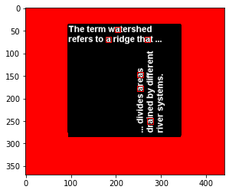

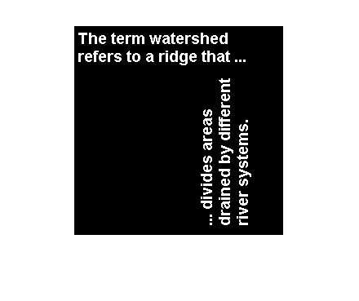

I use Correlation for Spatial domain concept

And

For Frequency domain I use the result of multiplying the frequency coefficients.

Basically frequency domain represents the rate of change of spatial pixels and hence gives an advantage when the problem you are dealing with relates to the rate of change of pixels which is very important in image processing. For example :high frequency in the frequency domain represents rapidly or sharply changing pixels such as boundaries or edges in an image. A high pass filter can be extremely helpful in identifying or removing these edges easily but the same problem is much more difficult in spatial domain (x-y domain). Similarly a simple low pass filter can be used to get a smoother image. As you can guess images can be easily made sharper or smoother by manipulating different parts of frequency domain.

Some points on why it is so powerful :

1. Frequency domain gives you control over the whole images, where you can enhance(eg edges) and suppress (eg smooth shadow) different characteristics of the image very easily.
2. Frequency domain has a established suit of processes and tools that be borrowed directly from signal processing in other domains.
3. Some tools used for even image recognition such as correlation , convolution etc are much simpler and computationally cheaper in frequency domain